


Supported Housing Officer
Priory Court, Knowle and Phoenix Place, Redcliffe

Hours: Full and part time positions available for the right candidates. Successful candidates may work across any of our services in Bristol. Our family service in Knowle is staffed 8-6 on a rota basis, Monday to Friday, whilst our other services operate 9-5, Mon-Fri.

Part of the: Support Services Department

Responsible to: Team Leader

Purpose
To deliver psychologically informed housing and support services to vulnerable women and parents who have a background of homelessness. This includes working with them to secure more permanent suitable move-on accommodation and supporting them to develop the skills to maintain their tenure successfully and contribute positively to the communities in which they live.

Responsibilities: A Supported Housing Officer will:
 | Establish and maintain trusting relationships with parents, maintaining regular contact and facilitating a co -produced planned programme of support. |  | Assess the support needs and risks of our residents in line with organisational Support Delivery and Risk Management procedures
 | Assist our residents to identify and access appropriate move on accommodation |  | Promote opportunities and encourage the raising of aspirations of the people you support in education, training and employment
 | Monitor and manage rent accounts, ensuring arrears are addressed in line with organisational procedure |  | Deliver welfare benefits and budgeting advice to parents to ensure their income is maximised and financial resilience and capacity increased
 | Participate in undertaking Health and Safety checks and inspections. Proactively contribute and support the Team Leader to ensure the service and building are in line with our Health and Safety Compliance Framework |  | Achieve individual KPIs whilst working in accordance with all relevant policies and procedures
 | Work in partnership with external agencies to facilitate the effective delivery of support and improve outcomes for those receiving our services |  | Use IT effectively, working alongside colleagues and the Team Leader to maintain an effective case management and monitoring system and contribute to reports as necessary
 | Safeguard the welfare of children, young people and vulnerable adults in line with organisational safeguarding polices and local procedures |  | Deliver a diverse and culturally sensitive service, promoting equality of opportunity within all aspects of the role and wider service
 | Be responsible for attending and completing mandatory and other required training, development and online courses, with a commitment to continual professional development |  | Work across services as and when required to ensure the delivery of the wider support service is maintained.
 | Work positively with change and contribute to the development of services as and when required.


Qualifications and Experience: In this role a Supported Housing Officer will need the following:
Team Leader will
 | Experience and understanding of the causes of homelessness and social exclusion for vulnerable women and parents |  | Experience of delivering tailored support to people in a supported housing environment
 | Up to date knowledge of Safeguarding and Protection from Abuse strategies as they relate to children and adults, with the ability to identify risk, including how and when to report concerns |  | Knowledge of Psychologically Informed Environments and practice
 | Experience and understanding of housing management issues including rent collection, void management, property maintenance and ASB |  | Experience of working as part of a team, with a strong commitment to joint working and flexible approach
 | Working knowledge of the welfare benefits system |  | Experience of assessing the strengths, support needs and risk of vulnerable people and facilitate a co -produced programme of support
 | Good level of IT literacy, experience of operating case management systems and ability to carry out own administrative workload. |  | Experience of promoting equality of opportunity and resident empowerment
It would be great if you could also: l

 | Demonstrate knowledge and experience of promoting parenting skills and healthy routines |  | Have experience of supporting people with mental ill health
 | Have experience of supporting people who are survivors of domestic abuse, or currently experiencing it |  | Have experience of delivering strength based and trauma informed support

Skills and Abilities: In this role a Supported Housing Officer will need the following:

 | Excellent communication skills, with the ability to communicate at all levels both orally and in writing, tailoring to induvial need when required |  | Excellent engagement skills coupled with the ability to identify barriers to engagement, break them down whilst respecting and paying attention to people’s needs
 | Ability to work in partnership with multiple agencies, including statutory agencies to improve outcomes for those receiving our services |  | Ability to maintain accurate and up to date records by using common Microsoft Office packages, Excel, Word, Outlook and other systems and software
 | Empathy with the causes of homelessness for vulnerable parents and the barriers they face. |  | Ability to identify and raise the aspirations of those receiving our services, encouraging education, training and employment
 | Ability to advocate for those receiving our services |  | Self-motivation and tenacity, with the ability to work under pressure at times, managing time and competing priorities effectively
 | A commitment and ability to work outside planned and scheduled hours as and when needed |  | Ability to positively work with change and contribute to the development of services as and when required, including gaining the views and involvement of those you support

It would be great if you could also:

 | Demonstrate experience and knowledge of participating in, and facilitating Reflective Practice |  | Have experience in writing concise and accurate safeguarding reports and a working knowledge of child protection case conferences and reviews

Values:
Elim’s customers include families and single people living in our properties for rent, young people undertaking apprenticeships or training, clients within our support services and people buying houses that we have developed, among others. We have the same aim for all these relationships: to ensure that the housing and services Elim provide serve as a platform for growth, facilitating all our customers to achieve their aspirations. In this way, we make our homes truly life changing by ensuring that our service has a positive impact long after a person has left Elim accommodation.
Elim CARES Values were created in partnership with our customers, staff, Board and other stakeholders, and they represent our commitment to how we deliver our services and work together successfully.
A Supported Housing Officer lives by the Elim CAREs values:

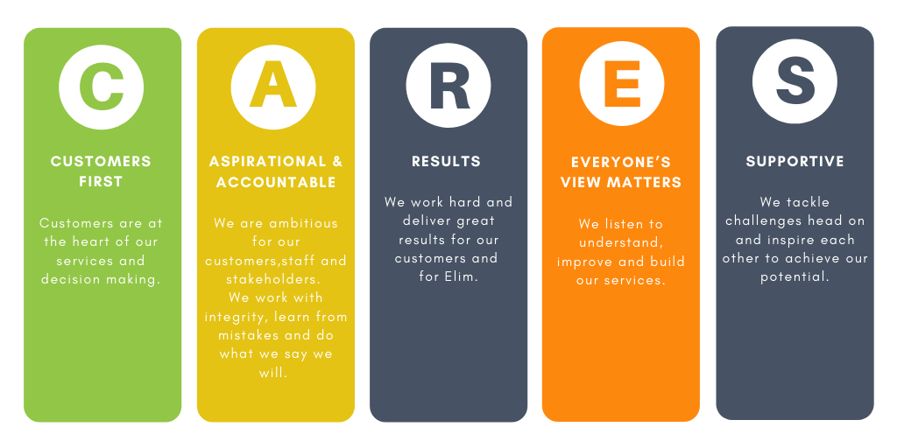



`


FLEXIBLE WORKING
We do all we can to encourage a healthy work-life balance.

GENEROUS ANNUAL LEAVE ENTITLEMENT
Employees receive 25 days paid annual leave, rising by 1 day for each complete year of service to a maximum of 30 days.

MILEAGE EXPENSES
We pay mileage expenses at a rate of 45p per mile.
LEARNING AND DEVELOPMENT
We believe in developing our staff and investing in your learning and training.



HEALTHSHIELD BENEFITS
Benefits available include: Employee assistance programme, healthcare cashback and shopping discounts
PENSION AND LIFE ASSURANCE
We are a member of the Social Housing Pension Scheme

