

CUSTOMER SERVICES COMMITTEE

INDEPENDENT MEMBER INFORMATION PACK

OCTOBER 2024

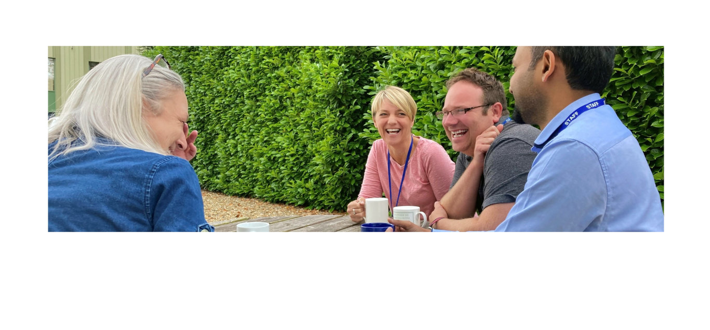

Welcome from the Chair
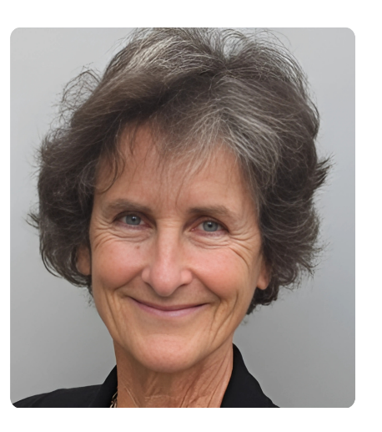
Thank you for expressing an interest in becoming an
Independent Member of our Customer Services Committee.

Elim Housing Association has just passed its 60th anniversary
year, and as we progress into our next decade of operation,
we are looking forward to all that we can achieve in the future.
The need for the homes and services we provide is more
important than ever, and we are committed to continued growth
and the delivery of more quality homes and services.

As a new Board or Independent Committee Member you will
be joining us at an exciting time. We want your support in
setting ambitious targets and guiding the team to the delivery
of our challenging objectives.

As a smaller housing association, customers are at the heart of our business and we want to encourage our customers to take-up roles on our Committees or Board so that they have the opportunity to shape and steer the direction of Elim’s housing service. I want this to lead to an increased level of trust that Elim’s services represent value for money and assurance that they genuinely respond to customer need.

This is why we are particularly looking for Independent Committee Members with current or previous experience as a customer of Elim Housing. Experience as a customer of an alternative local Housing Association would also be welcomed.
All Board and Independent Committee Members must be able to demonstrate a commitment to our values and support our vision.

Additionally, we want to build the diversity of the Board and we warmly welcome applicants that reflect the communities we work in.

Attitude and values are as important as technical skills, so if you believe that you are not the sort of person that would normally be on the Board or Committee of a housing association, you might be just the person we are looking for.

I hope you are as excited as I am by these opportunities and will feel encouraged to apply for the role. You will hear from some of our existing Board and Independent Committee Members later in the pack.

Sally Mason (Board Chair)

Introduction

This information pack is designed to provide you with a little more information on Elim Housing Association, our Board and Committee governance structure and the Customer Services Independent Committee Member role.

We are happy to discuss any aspect in more detail with you before you apply – please contact Alishia Augustine on a.augustine@elimhousing.co.uk . If you are recruited to the Board, full induction training will be given and we will provide more detail on the information in this pack.

About Elim Housing

Our vision is to meet housing needs and deliver homes that change people’s lives.

Elim Housing Association was established in 1963. Today, Elim provides homes and housing services to over 900 households across 11 local authority areas in England and Wales. Our customers include individuals and families in social rented or shared ownership homes, people with experience of homelessness who are living in our supported housing and Gypsies and Travellers living on specially developed sites that Elim have built or manage on behalf of another Local Authority. Each year we also work with over 150 hospital inpatients in housing need, helping them to find appropriate accommodation on discharge.

In 2016 Elim launched its commercial subsidiary, Lime Property Ventures. Its purpose is to develop homes and generate profit for reinvestment in the social objectives of the Elim Housing Group. It also provides 22 apartments for student accommodation in the centre of Bristol.

We are a small association with large ambitions. Over 60 years since Elim began, we remain true to our values and add value in the areas we serve. We are particularly proud to deliver homes and specialist services that may be otherwise overlooked, due to scale or complexity, by other housing providers.

For further information about Elim Housing and the breadth of services we provide, please visit our website www.elimhousing.co.uk



Our Values

Elim CARES Values were created in partnership with our customers, colleagues, Board and other stakeholders. These values set out how we aim to deliver our services and work together successfully.

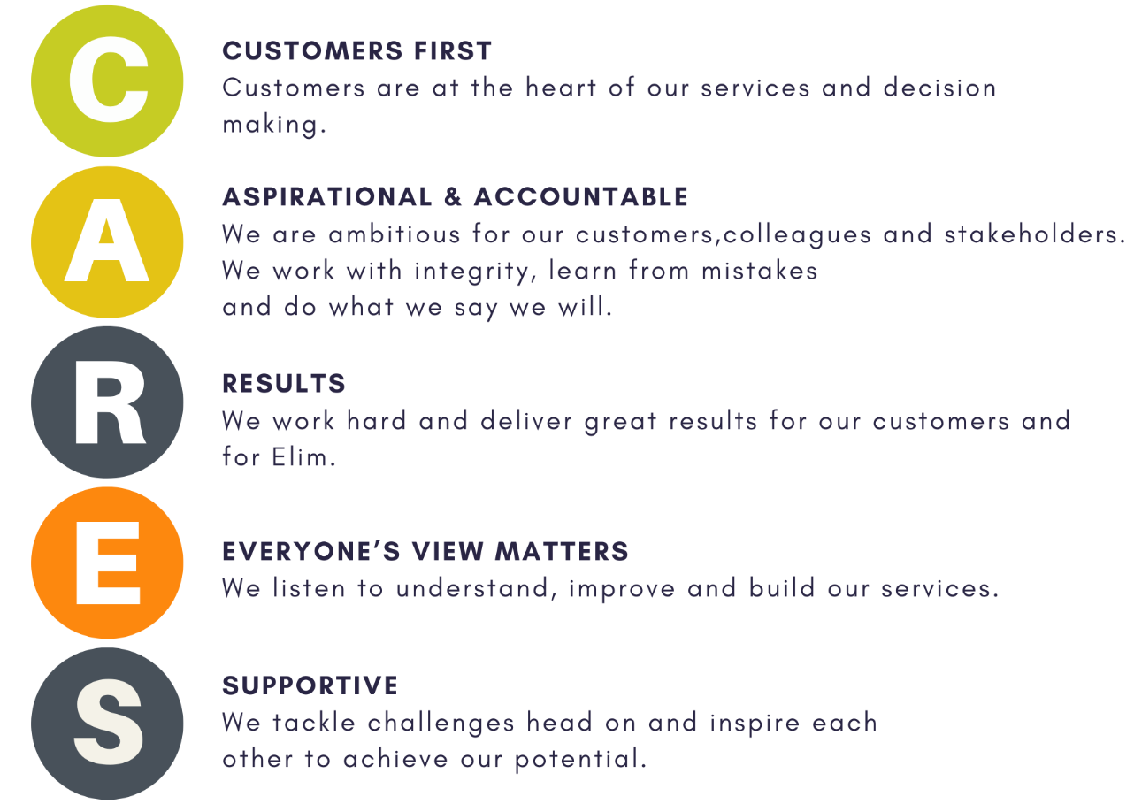



Our Plan for the Future

Elim is a small association with large ambitions and we hope these are captured in our 2023 – 2028 Corporate Plan. In the context of the economic uncertainty and social challenges of the current environment, we believe this plan and our vision to meet housing need and deliver homes that change people’s lives is more relevant than ever.

Over the next five years Elim will continue to evolve and grow. We will increase the number and quality of the homes and services we offer, and we will work with a diverse range of customers, colleagues and other stakeholders to provide affordable homes that meet customers’ needs.

What will this mean for Elim?

Increase In Size: We expect Elim to reach over 1000 homes under our ownership or management by 2028. This will enable us to meet the housing and support needs of more individuals and families across the areas where we work.

A Diverse Workforce: We are working to ensure that our organisational diversity reflects our customers and the geographical areas we work in. This will help us ensure that our services and processes help meet the different needs of the people we serve.

A National Provider: Elim is one of the largest national providers of affordable housing for the Gypsy Roma & Traveller community. We will play our role in national networks to share and to learn from good practice and to advocate for our customer groups.

Customer Engagement: We will do more to involve our tenants and other customers in guiding our services both at an organisational and a local level.

Specialist Services: More of the homes we build will provide for individuals with specialist needs, as identified and commissioned by our stakeholders and commissioners.

Digital Push: We will expand the channels available for customers to contact us and improve our use of technology to increase efficiency and service delivery.

You can find out more in our 2023 - 2028 Corporate Plan which is available for download here.

How are the Board and Committees organised?

The primary purpose of the organisation is to provide social housing - often referred to as affordable housing - which can be for rent or sale. The maximum level of rent that can be charged by housing associations is set by the Government. Rents are set at levels that allow people with fewer choices in the housing market to afford them.

The Board currently has 12 members including the Chief Executive. The usual maximum number of consecutive three year terms that a Board member can be on the Board is two, which limits service to six years in total. In exceptional circumstances members can serve an additional term of three years by agreement with the Board. In addition to the Chair and Vice Chair roles, we have 3 members who chair the sub-committees and a Board member who sits on the Lime Property Group Board.

The Board meets at least four times a year, with meetings lasting 2-3 hours. The meetings can be attended in person or online. There are also up to two annual Strategic Planning Days and opportunities to attend occasional Elim events and other meetings.

Each Board member will typically become a member of one of Elim’s sub-committees.

We have four sub-committees:

- The Customer Services Committee: this focuses on our customers’ experience of Elim’s services including our housing management, supported services and our repairs and asset management services. This committee meets four times a year.

- The Finance, Risk and Audit Committee: this focus on the governance of our financial arrangements and our management of risk across the organisation. This committee meets four times a year.

- The Development and Growth Committee: this focuses on opportunities to increase the number of homes and services we deliver – this may include monitoring of our acquisition or build programme. This committee meets twice a year.

- The Organisational Development Committee: this focuses on our HR and IT services, ensuring we have the right people, systems and digital infrastructure to deliver our objectives. This committee meets twice a year.

The committees are made up of Board Members, the Executive Team and Independent Committee Members which bring a specific focus to the work of each committee.

Our Independent Committee Members do not attend the quarterly Board Meetings but are invited to attend Strategic Planning Days and other events.

What is the role of the Board?

The purpose of the Board is to direct and control the organisation’s affairs. The Board sets the overall aims and objectives and ensures that the organisation is meeting them and complying with legal requirements promoting the lasting interests of the organisation.

The Board does not run the organisation on a day-to-day basis as it has paid professional staff to do this. The Chief Executive and the Executive Team are responsible for the operational management of the organisation. The Board delegates full operational powers to the Chief Executive to act and authorise decisions on its behalf.

The Board’s key functions are to:

- Define and ensure compliance with the values and objectives of the new organization.
- Establish policies and plans to achieve those objectives.
- Approve each year the Budget, Financial Statements and Annual Report, before publication.
- Establish and oversee a framework of delegation and systems of control.
- Make decisions that might create significant financial or other risk to the organisation, or which raise important issues that might clash with our vision and values.
- Monitor the organisation’s performance in relation to the plans, budgets, controls and decisions.
- Appoint (and if necessary, dismiss) the Chief Executive and be represented in the appointment of key second-tier managers.
- Satisfy itself that our affairs are conducted lawfully and in accordance with generally accepted standards of performance and propriety.
- Ensure compliance with statutory and regulatory obligations, including equal opportunities.

What is the role of the Commitees?

The four committees meet before the Board Meetings are scheduled to take place. The Board delegates some decision making to the committees, but their main role is to explore the areas of committee focus in more detail, to monitor organisational performance and to report any exceptional issues to the Board.

The Committees key functions are to:

- To oversee and proactively direct, where appropriate, the Group’s business, monitor outcomes and provide reassurance to the Board in their respective areas.

- To ensure delivery of the group’s plans for internal and external audit, growth and asset management and the Group’s organizational design to deliver excellent customer service respectively.

- To ensure that there are suitable frameworks in place for the Executive to manage the organisation and to also promote efficiency, good practice and deliver improvement.

- To provide reports to the Board and other Committees on various matters within their remit.

Do the Board and Independent Committee Members receive payment?

Independent Committee Members do not receive payment.

Board members receive an annual payment for their role. This payment is currently set at £2500 per year. This sum is determined using external advisors who provide information on levels of payment across the sector.

Both Board and Independent Committee Members can claim travel, childcare and other expenses incurred by them in connection with their attendance at Board or Committee meetings. We will give you full details on the procedures and claim forms covering both the claiming of expenses and any payment once you have been appointed.

Do I need to have previous experience as a Board or Independent Committee Member?

No previous experience is required - it is more important that you share the values of the organisation and are willing to bring the benefit of your own unique perspective to the Board or Committee.

We want individuals who are willing and confident to challenge existing thinking in a positive way so that the Board and the organisation can get the benefit of different experiences and backgrounds. Working together is also key to a successful Board and Committee as well as the ability to stand back and look at the bigger picture. We are committed to providing support and training for those individuals stepping into a board role for the first time.

More guidance on the skills, knowledge and personal qualities of the role of Board and Independent Committee Member s is attached in the role profiles in appendix 1.

Our Current Board

The Board must have a diverse range of skills, qualities, experience and knowledge to function effectively. However, we do not expect Board Members to have skill or experience in all areas. We will provide coaching and support in areas such as governance or finance, which are key areas of focus.

We currently have 12 Board Members including the Chief Executive. For some Board Members, has been their first experience of being on a Board, others bring experience from different areas such as School Governors or charities.

We have Board Members with financial expertise and knowledge, IT and Digital specialism and experience of property development. Other Board Members have some experience of social housing and others bring different perspectives from the private sector. We are all also customers and bring a variety of views on excellent customer service to ensure the best outcomes for our own Elim customers. All Board Members share a commitment to social housing and providing the best possible outcomes for our Elim customers.

To learn more about the individuals making up the Board, have a look at our website https://www.elimhousing.co.uk/about-elim/elim-housing-board/

Our Independent Committee Members make a hugely valuable contribution by bringing their own experiences and knowledge to our committees on a more detailed level than the Board members. It is an ideal stepping stone to becoming a Board Member and understanding more about what is involved.

We always welcome applications from our own customers on both the Board and Committees.

Creating a Diverse Organisation

Our aim to create a diverse workforce at every level of the organisation includes our Board and Independent Committee Members. We have a working group to focus on our Equality, Diversity and Inclusion plans and strategy that reports to the Board to help us achieve our objectives in this area.

Our Chair has signed up to the National Housing Federation’s “Chairs Challenge”, which is a public commitment to take the Board on a journey to understand how diverse and inclusive we are and develop a vision for the future.

What considerations have you made on accessibility for Board Members?

Most meetings take place in our Head Office which is designed to be accessible. Meetings are also accessible online. If we arrange meetings in other venues, our Board, Committee Members and colleagues requirements are also taken into account when choosing that venue.
Board papers can be available in larger print, and we would are also able to make reasonable adjustments based on individual requirements.

Do Board and Independent Committee Members receive training and induction?

Elim will provide development and training for all Board and Independent Committee Members as soon as they are appointed. All new members will be provided with an induction pack which includes our Corporate Plans, key strategy documents and relevant policies. You will be invited to meet the Company Secretary and Chief Executive as part of their induction. The induction plan will include a review of the first papers and principal issues for the next Board or Committee meeting as well as a

chance to meet residents and staff. There is also an annual training programme for Board and Independent Committee Members.

We can facilitate attendance at National Housing Federation training events designed for Board and Independent Committee Members and we provide financial support and cover all expenses for Board and Independent Committee Members to attend sector conferences as well as tailored sessions on relevant topics prior to a Board or Committee meeting. We can also arrange for you to ‘shadow’ Elim colleagues and ‘buddy’ with an existing Board member to learn more about the organization and the role.

How frequently should I attend Board/Committee meetings?

Board members must be committed to attending at least 75% of all Board and Committee meetings and both Strategic Planning Days in a year. Independent Committee Members should attend at least 75% of the Committee meetings. Given the limited number of meetings the Chair hopes that board members will exceed this minimum requirement. The agenda will be sent to you at least five days in advance of the meeting, electronically, and it is expected that you will have read all the reports in advance of the meeting.

How does the Board operate?

A Housing Association is governed by Rules setting out its purpose and how it operates. It must also adhere to legislation and the requirements of its regulator, the Regulator of Social Housing.

We also have a framework of internal best practice policies and procedures. In common with much of the not-for-profit sector, Board members are expected to operate to the highest standards of probity, and this means that they cannot obtain personal or family gain from their Board position. We have clear processes in place to explain to board members their particular duties in this respect.

Will I be personally liable?

Independent Committee Members are not required to be shareholders and hold no voting rights.

Are we a Charity or Company?

We are a Community Benefit Society registered with charitable rules. This means that we are regulated by the Financial Conduct Authority and the Regulator of Social Housing rather than Companies House or the Charity Commission.

Find out more from some of our current or recent Board and Independent Committee Members below.

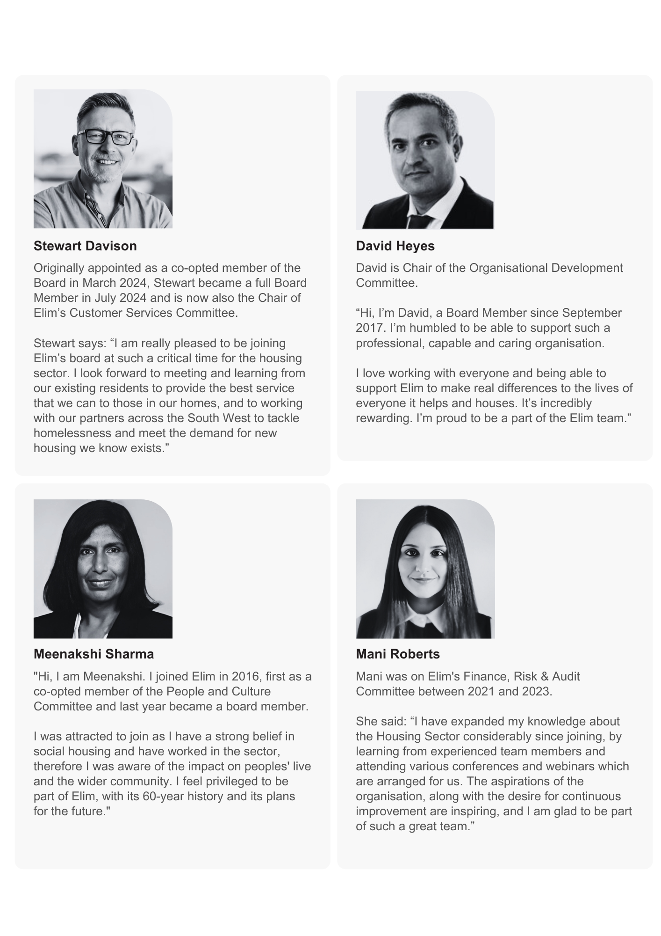

Independent Committee Member role information:

Role Profile – Independent Committee Member
Purpose of role
The Committees are responsible for the direction and control of the organisation and each individual Independent Committee member must carry out their duties and responsibilities in accordance with the constitution of the organisation, the law and regulatory requirements. We would like you to have an interest in social housing and the motivation to make a difference.

Core tasks and responsibilities
As a minimum, we ask that all Independent Committee members:

- devote sufficient time to Committee work, including preparing for and attending meetings, training sessions and other events as required.
- consider and understand documents, tables and statistics.
- challenge and ask questions.
- work as part of a group.
- listen to and respect the contribution of others and contribute to group discussion.
- be flexible and support collective decisions.
- uphold the vision, values and objectives of the organisation.
- act professionally, with integrity and in the best interests of the organisation.
- maintain confidentiality.
- adhere to the principles and practice of equality, diversity and inclusion.
- commit to involving and consulting residents and stakeholders.
- adhere to the National Housing Federation (NHF) Code of Governance and NHF Code of Conduct.
- be able to respect boundaries between executive (staff or day to day) and governance functions.

Independent Committee member responsibilities vary according to the purpose of the committee but include:

- reporting to the Board with recommendations, advice and risks.
- defining and ensuring compliance with the vision, values and objectives.
- advising on strategies, policies and plans to achieve the vision, values and objectives.
- approving each year’s budget and accounts.
- establishing and overseeing an appropriate framework of delegation and control.
- making decisions that might create significant financial or other risk to the organisation or which raise important issues that might clash with our vision and values.
- monitoring organisation performance in relation to outcomes, plans, budgets and decisions.

- read and digest reports prepared by staff and advisors and contribute to appropriate debate of key issues amongst Committee members to ensure decisions are well founded.
- attending induction and at least 75% of meetings.
- participating in activities that will develop skills and knowledge (such as training and appraisal).
- acting as ambassadors for the organisation and not taking part or being involved in activities which may bring organisation into disrepute.
- acting with the same skill and care as any prudent person managing their own personal business affairs.
- ensure key principles of diversity, inclusion, involvement and empowerment are evident in decision making.

Each Committee member must act only in the interests of the organisation and not on behalf of any constituency or interest group. No one who serves as a committee member should be in a position to gain or benefit from their dealings with the organisation.

Independent Committee member skills, qualities, experience and understanding
Each Committee is delegated to focus on a different area of Elim’s operation. Each Committee is looking for individuals who can support in the following areas:
Customer Service Committee:
- Customer Services.
- Housing Management and Supported Housing Services.
- Asset Management (Property condition and maintenance).

Finance and Risk Committee:
- Legal and governance matters.
- Financial and treasury issues.
- Risk and performance management.

Development and Growth Committee:
- Property development.
- Property acquisition and new business opportunities.

Organisational Development Committee:
- Human Resource, business transformation and culture.
- IT, Digital and system infrastructure.
- Communications, marketing and public relations.

All our committees welcome those with direct experience of social housing and have commitment to the mission and values of the organisation as a not-for-profit charitable housing association. Training and support would be given in all cases to ensure committee members feel able to comment on and participate fully in committee work.

- read and digest reports prepared by staff and advisors and contribute to appropriate debate of key issues amongst Committee members to ensure decisions are well founded.
- attending induction and at least 75% of meetings.
- participating in activities that will develop skills and knowledge (such as training and appraisal).
- acting as ambassadors for the organisation and not taking part or being involved in activities which may bring organisation into disrepute.
- acting with the same skill and care as any prudent person managing their own personal business affairs.
- ensure key principles of diversity, inclusion, involvement and empowerment are evident in decision making.

Each Committee member must act only in the interests of the organisation and not on behalf of any constituency or interest group. No one who serves as a committee member should be in a position to gain or benefit from their dealings with the organisation.



